Gen9 Integration steps

Basic steps (Before integration):

Step 1: Request project PCM to send the TCM project stand path, BB number and CS-IS number of the integration/development project.

Note: Before going to change anything in the software we should create CR for project tracking and changes should committed and analyzed by CRP and CR must be in accepted by PCM.

Please check the below link for creating the CR in CSCRM.

\\bosch.com\dfsrb\DfsIN\LOC\Kor\NE1\NE1_Info\41_EAR\10_Projects\BSW_FBL_DIAG\10_Development\Info_exchange\09_Trainings_Tracker\01_TrainingMaterial\09_Basics_For_Bootloader\Gen9_training_doc\CS-CRM_Training_Slides.ppt

Step 2: Copy and Paste the TCM project stand path in VM (Version management) and select the project and give right click on it and we will get option like selection🡪 get and select get option.

Step 3: Create a folder in CM (configuration management) and give a name for that folder with your project name. Right click on folder you will get option like insert selection and select the insert selection, finally we can see the project in our configuration management.

Step 4: Right click on the project and select the option get for work (to get the whole project into your local PC).

Step 5: Before going to development or integration we should check the software first, for that first need give generate file list and import the project in sharCC and try to build the software.

Example:

1) Request project PCM to send the TCM project stand path, BB number and CS-IS number of the integration project.



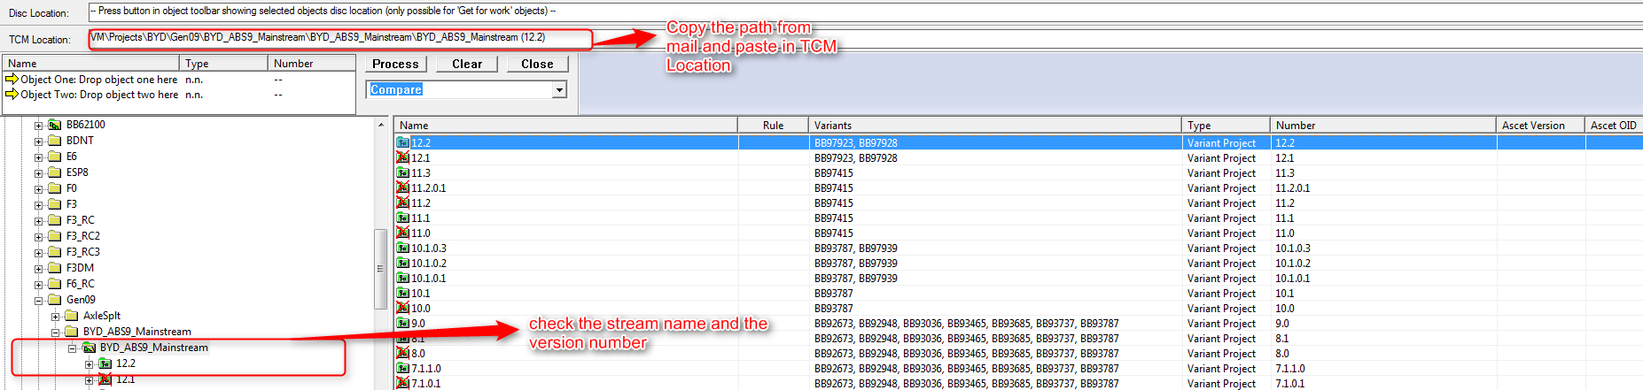2) Copy and Paste the TCM project stand path in VM (Version management).

After that select the project and give right click on it and we will get option like selection🡪 get and click on get option.

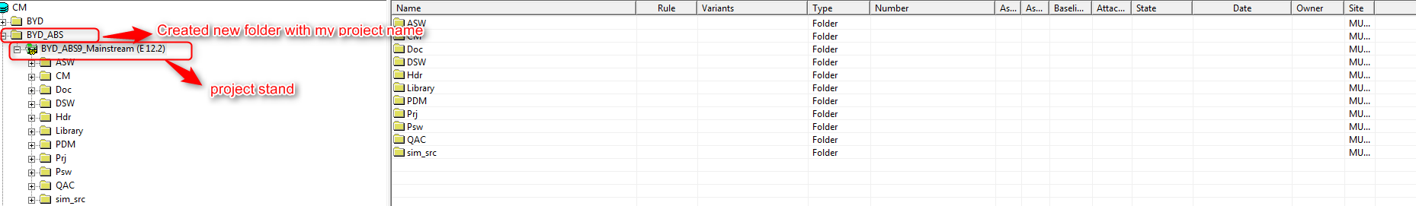3) Follow the step 3 and step 4 for getting your project into your local.

5) Before going to development or integration we should check the software first, for that first need give generate file list in the TCM and import the project in sharCC and try to build the software.

6) After completion of build success, checkout the software and integrate our boot component in the software.

Integration steps:

Two types of integrations are there

1) Complete integration

2) Signature update

**Case 1:** please check the below link for complete integration of bootloader component

\\bosch.com\dfsrb\DfsIN\LOC\Kor\NE1\NE1_Info\41_EAR\10_Projects\BSW_FBL_DIAG\10_Development\Info_exchange\09_Trainings_Tracker\01_TrainingMaterial\09_Basics_For_Bootloader\Gen9_training_doc\IntegrationSpecification_Template_v01.pdf

**Case 2:** For signature update

1) Import the Flash Krypto with the extension of your BB number folder into your flash component

2) Import the add_hexfile.xml with the extension of your BB number files into PRJ/GEN09_config folder

3) Do the variant management for your Flash Krypto and add_hexfiles.xml files

4) Update the MTC_configuration file and check the your project name and BB number is available or not in your build configurations

Example: signature update for BYD project and variant number is BB98030.

1. 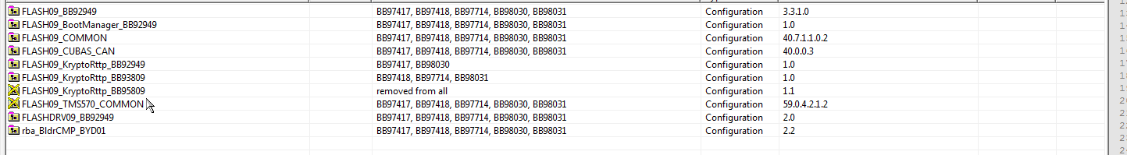Initially our component like below
2. Import the Flash Krypto with the extension of your BB number folder into your flash component.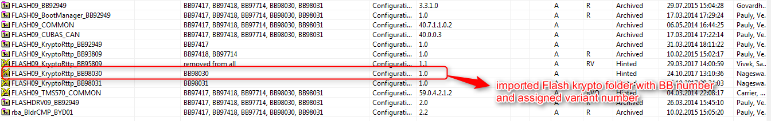
3. Change the public key file and signature key file names with your BB number extension
4. In public key file we should change the signature Key and the key name.

In signature file we should change only the name of the Key

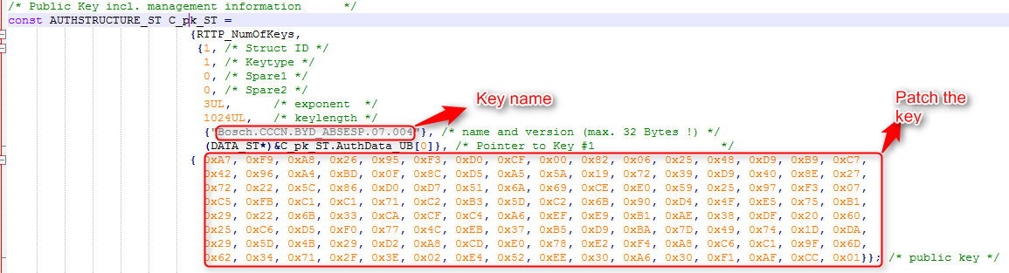Note: Flashdrv Krypto file requires only if in case of external swil concept in the project.

Fig: Flash Krypto public key file.

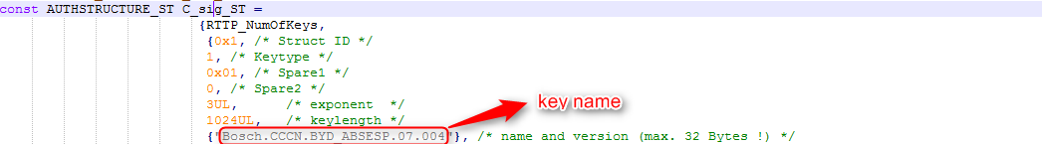

Fig: Flash Krypto signature file

Note: Don’t change the key in flash Krypto signature file and need to change the key only in flash Krypto public key file.

1. Import the add_hexfile.xml with the extension of your BB number files into PRJ/GEN09_config folder and assign our variant to the imported files

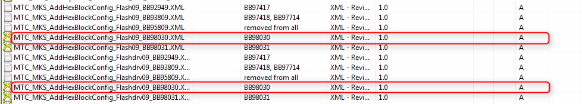

Note: after mapping our variant number to the imported files, should remove our variant number in other add_hexfile.xml files.

We should include our Flash krypto.c or flashdrv krypto.c file in the add_hexfile.xml files

1. include flash krypto.c file in add_hexblockconfig_flash09.xml file



1. Include flashdrv krypto.c file in add_hexblockconfig_flashdrv09.xml file



1. Update the MTC_configuretion file and add the flash add_hexblock.xml file and flashdrv add_hexblock.xml file information in every build configurations.

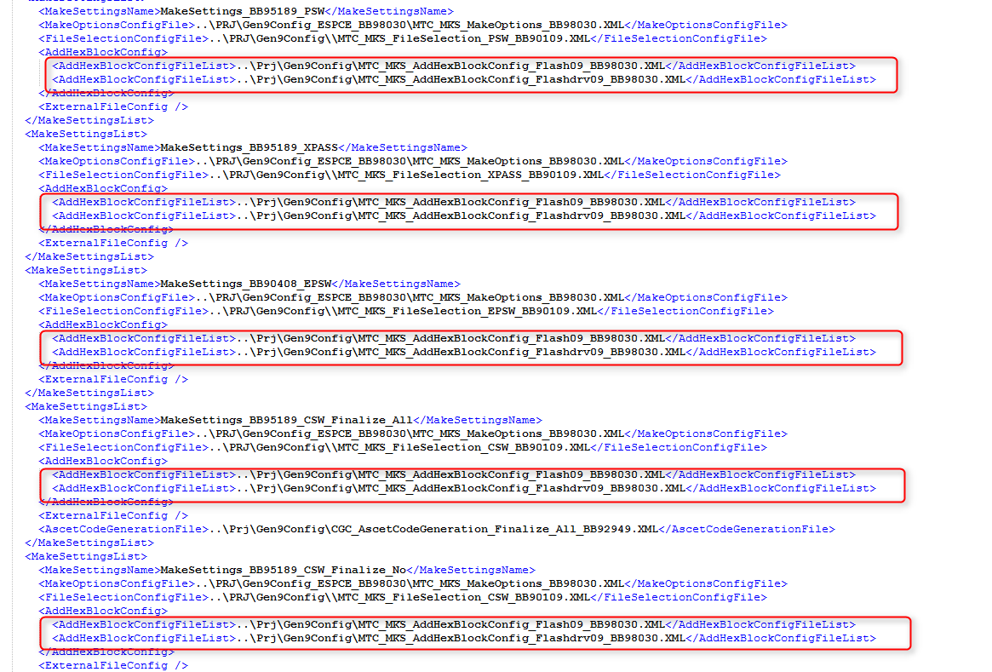

1. Check in the customer name and BB number mapped correctly in the makeoption.xml file and if the customer name and bb number is not mapped then we should map the according to customer specifications.

After Integration :

1. After completion of the integration, give a ECB build

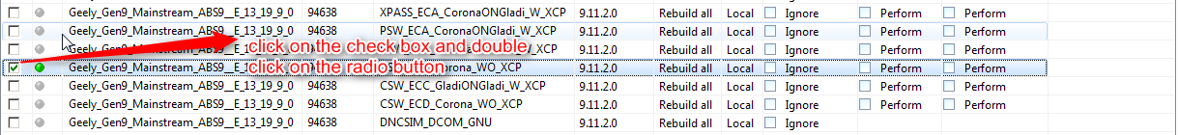

1. Test the software in the LAB and its works successfully, check-in the software in TCM.
2. 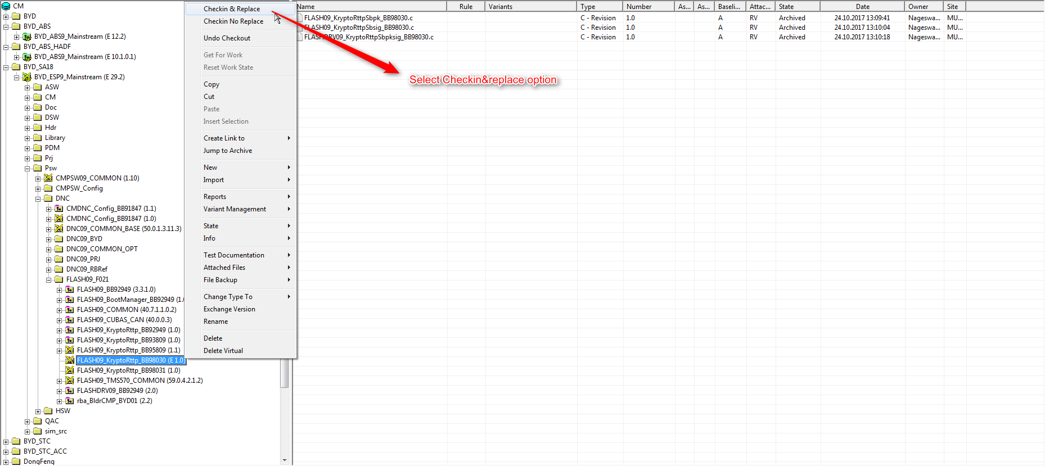Right click on the file or folder in TCM, we will get first option like Check-in & replace and select that option
3. We will get reserve number window and click on default option it will take next default value in the reserve number and click on Ok button

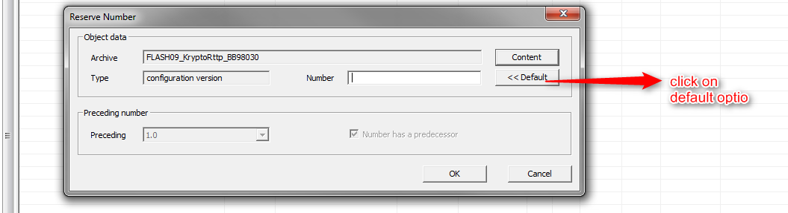

1. We will get window like new test documentation and simply click on OK button

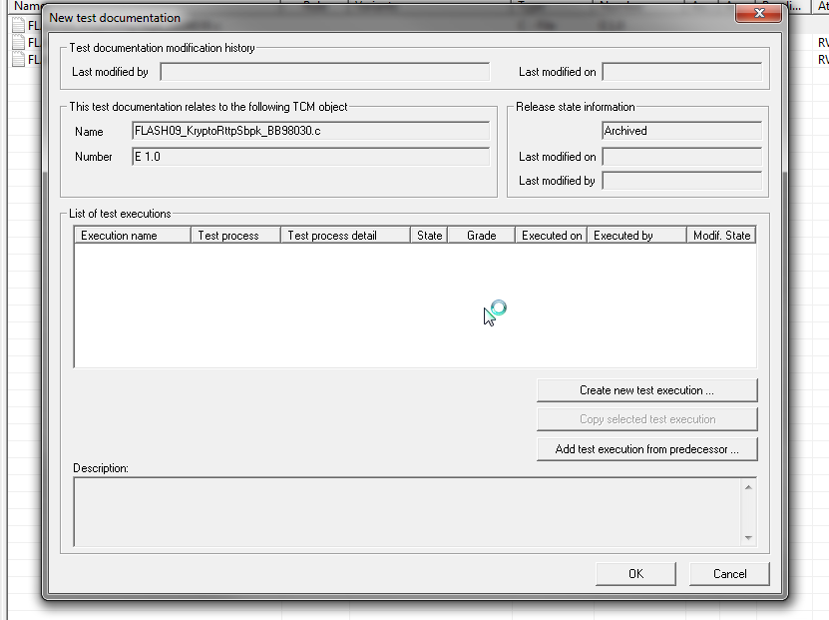

1. We will get change documentation window and fill the details and click on OK button

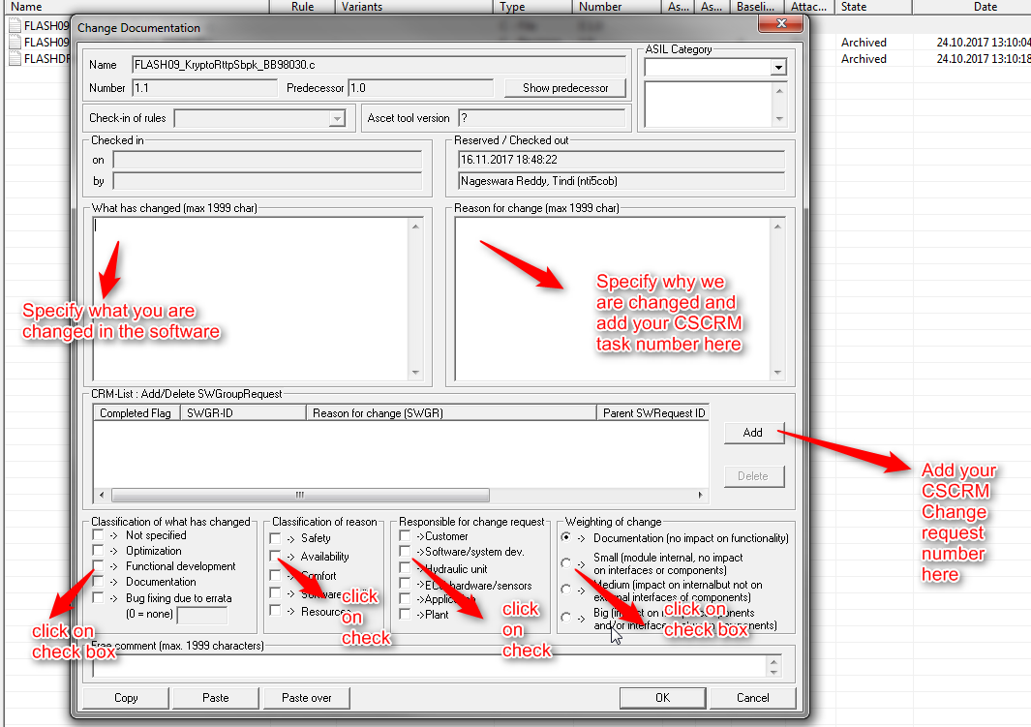

Note: After this we will get check-in successful notification and please check you version number is changed or not with your name.